Marr Mac Hair & Makeup Guide
For the Year End Show
Costume Tips for All Ages
- Costumes were sent home steamed; please ensure they stay wrinkle free for the show.
- Clean shoes, laces tied and tucked in
- Ensure your dancers body is free of any temporary tattoos, swim test marker, nail polish, & jewelry
- Clean tights free from holes and snags
- Tights Color ~ BALLET ~ Ballerina Pink JAZZ/TAP/LYRICAL ~ Tan (unless the Teacher has communicated something unique for a particular costume)
Hair Tips for All Ages
**A good tip is to spray the hair with water, which will help pull back all the little fly away pieces, the neater the hair the better!!
How to make a Ballet Bun Video https://www.youtube.com/watch?v=3yG7Hcozrf8
Makeup for All Ages
**If your dancer is wearing a mask on stage, only the eye make up is needed!
Why do Dancers need make up on the stage? Makeup is a necessity on stage for Dancers because the powerful stage-lighting systems may remove all colour from a performer's complexion and will eliminate shadows and lines. Makeup restores this colour and defines the facial features to ensure a natural appearance.
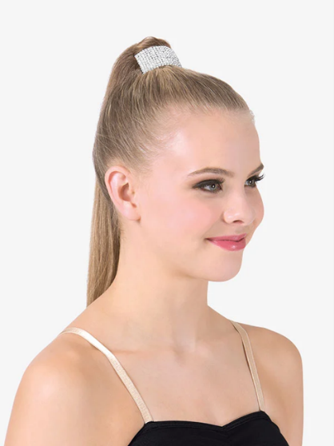 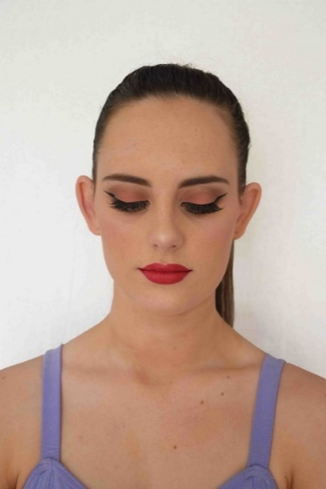 Examples of makeup *please use more blush

Creative Movement – Primary (ages 3-7)
Makeup: NO makeup is required for this age. Families may choose to add makeup if they wish. Hair: Girls should have a high bun in their hair. If you are unsure of how to make a bun, please see the video posted. If your daughter has bangs that are short, they may stay forward but if their bangs cover their eyes, please pull them back into the bun.
If your daughter’s hair is too short for a bun, please have the sides pulled so that their hair is off their face. All clips or elastics must blend in with the color of their hair.
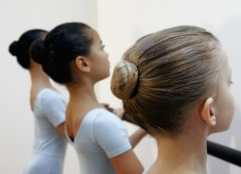
V Prep – Level 1 (ages 8-10)
Makeup: blush on the cheeks, brown eyeshadow on the eyelid, black mascara on top and bottom lashes, red lipstick, and (optional) black eyeliner with a small wing. Please see attached reference picture (more blush than picture)
Hair: Same as Creative Movement - Primary
Level 2 – Level 6 (ages 10+)
Makeup: Foundation (optional), pink blush, brown eyeshadow, black eyeliner, black mascara or fake eyelashes (preferred), & red lipstick.
Hair: Two French braids into a low bun. The bun should be right down by the nape of the neck and the braids should run along the “top edges” of the head, between the crown and the temples. Bangs must be slicked/pinned back (no bangs). 