Mini Summer Camps 2020 for 3-7 year olds
Our camps are designed for those children, whose preferred method of transportation is twirling, skipping, and leaping around your house; who can be seen holding a wand in one hand and a crayon in the other.
These camps are for those FINE ARTS kids who love everything about Singing, Dancing & Crafting.
Come join us this summer for some Fine Arts FUN!!
Marr-Mac Dance and Theatre Arts has been selected from ‘Canadian Kids Activities’
website as one of our most Popular Kids Activities!
Click on logo above to find out more

Camp #1
July 13th – 17th
5 Days 9:30 am - 12:00 Ages 3-7 years

Instructors: Christina Breault/ Dasha Rozdestvensky
$225.00 (plus GST)
Camp #2
July 27th – 30th

4 Days (Monday – Thursday) 9:30 am - 12:00 pm Ages 3-7 years
Instructors: Christina Breault/ Dasha Rozdestvensky
$195.00 (plus GST)
Camp #3
August 17th – 21st
5 Days 9:30 am - 12:00 pm Ages 3-7 years

Instructors: Dasha Rozdestvensky & TBD
$225.00 (plus GST)

Detailed Activity Schedule
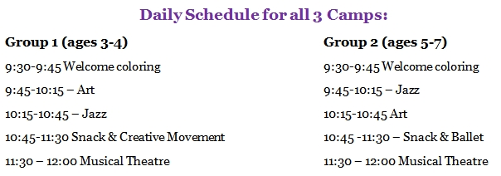
Registration & Payment
Register online: click the registration link to proceed online. Submit payment by: E-transfer or
Mail a cheque payable to Marr Mac Dance.
Register by mail: download registration form from the website, mail it with the camp fees to
Marr-Mac Dance
8627-109 St.
Edmonton, AB
T6G 1E7
Payment in person: Come into the studio to make a payment with cash, debit, or credit card.

*E-Transfers can be emailed to 1968@marrmac.com, password: registration

*No refunds after June 1st. All refunds will be less a $30.00 Registration fee.

